**Lab Week 02**

**Python Installation**

**Download and install Python**

*1. Go to official Python download website* [*https://www.python.org/downloads/*](https://www.python.org/downloads/)

*2. Download the latest version (or appropriate version) based on your OS.*

*3. Once downloaded, depending on your OS, get the file on your download folder.*

*4. Execute the installation file. Make sure that the global path is set in the options.*

**Run and Test Installed Python**

*1. There are many ways to test Python:*

* *use Python shell command line*
* *use Python (IDLE Integrated Development and Learning Environment)*
* *use Windows Command Prompt*

*2. To use Python shell, click*

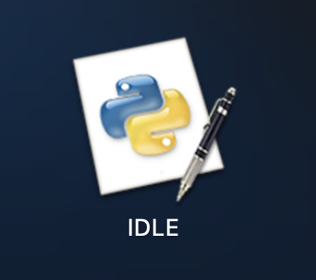

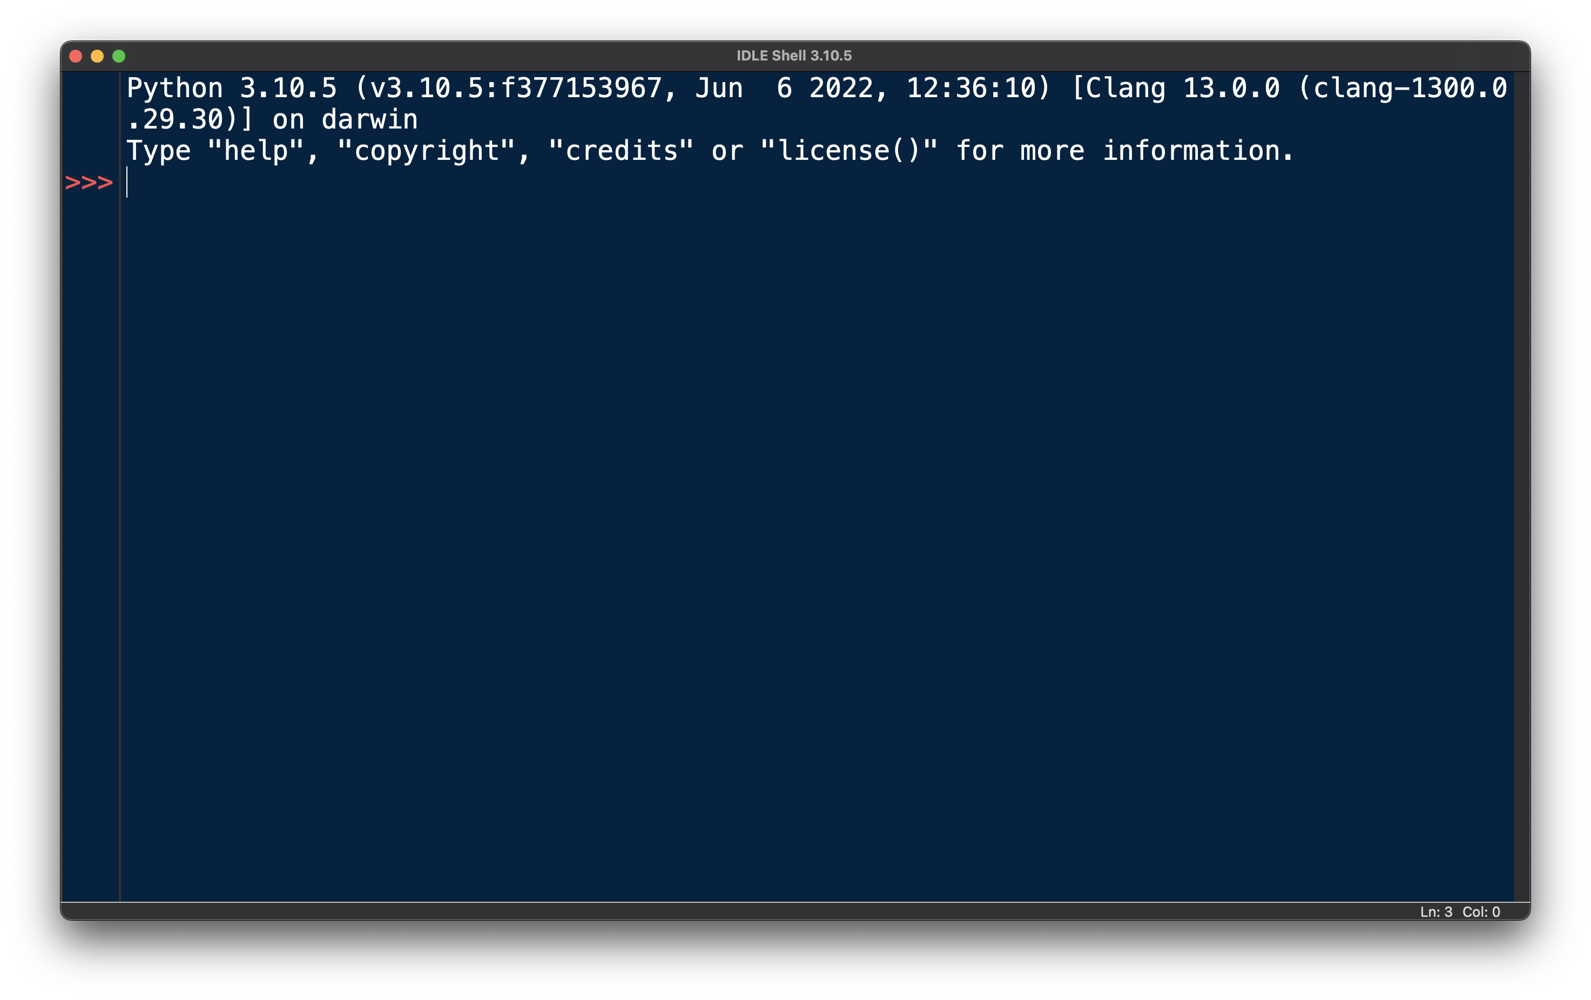

*At the Python shell prompt (“>>>”), type* ***print (“Hello Buddies”)*** *and press enter. You should get*

**Hello Buddies**

*3. Python IDLE can also be used as Python shell command with advantages of syntax color highlighting.*

**Create a Python Program/Application File Using Visual Studio Code**

1. *Using VS Code, click* ***File****, then* ***New File****. A new window opens and then save as* ***example.py****. Type the following code.*

1. *To Run Python File, click on the Play button on the right-hand side.*

**Example Program**

1. *Create a program called MySum.py that reads two numbers and output the sum of the two numbers. Write the pseudocode and draw the flowchart of the program before writing the code of the program.*
   1. Identify the input, output, and the process of the program.
      1. Input : Two numbers
      2. Process : Summation of the two numbers
      3. Output : The answer
   2. Write the pseudocode of the program
      * 1. INPUT number_1
        2. INPUT number_2
        3. total = number_1 + number_2
        4. OUTPUT total
   3. Draw the flowchart of the program

* 1. Write the code of the program

Output:

**Exercise**

1. *Create a program called* ***MyCalculation.py*** *that reads three numbers and output the product (multiplication) of the three numbers. Output example*
2. x 2 x 5 = 30

*Write the pseudocode and draw the flowchart of the program before writing the code of the program.*

1. *Create a program called* ***CalcAreaCircle.py*** *that ask the user the radius of the circle and calculate the area of a circle. (Note: π = 22/7)*

*Write the pseudocode and draw the flowchart of the program before writing the code of the program.*

1. *Create a program called* ***CalcVolumePyramid.py*** *that ask the user the length, the width and height of a pyramid to calculate the volume of the pyramid. Given the formula of pyramid*

*Write the pseudocode and draw the flowchart of the program before writing the code of the program.*

- The End -